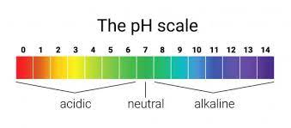
Rubric: Acid, Bases and Buffers
Informal Lab

/5 Labelled and coloured diagrams of Observations (Part 1 #7)

/5 Labelled and coloured diagrams of Observations (a). pH value (b). colour and (c). volume mL (Part 1 #8)

/4 Labelled and coloured diagrams of initial observation of test tubes (Part 2 #11)

/4 Data table with number of drops of NaOH and HCl (Part 2 #14-17)

/4 Labelled and coloured diagrams of final observation of test tubes (Part 2 #21-22)

/4 Data table with pH and number of drops of NaOH and HCl added to test tubes (Part 2 #21-22)

/12 Procedure Questions Part 1 & 2: (a) to (l)

TOTAL / 38

Rubric: Acid, Bases and Buffers
Informal Lab

/5 Labelled and coloured diagrams of Observations (Part 1 #7)

/5 Labelled and coloured diagrams of Observations (a). pH value (b). colour and (c). volume mL (Part 1 #8)

/4 Labelled and coloured diagrams of initial observation of test tubes (Part 2 #11)

/4 Data table with number of drops of NaOH and HCl (Part 2 #14-17)

/4 Labelled and coloured diagrams of final observation of test tubes (Part 2 #21-22)

/4 Data table with pH and number of drops of NaOH and HCl added to test tubes (Part 2 #21-22)

/12 Procedure Questions Part 1 & 2: (a) to (l)

TOTAL / 38

